Big service in a small town for 57 years
Tuesday, September 20th, 2011 | Posted by Mary Jo Winter
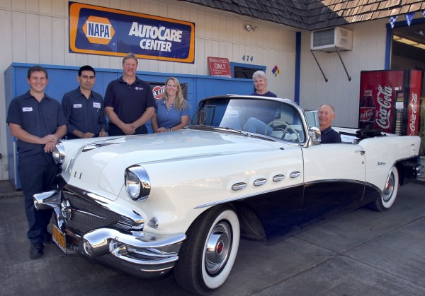
R B Southard is behind the wheel of his 1956 Buick with his wife, Marlys. Employees (from left) Josh Robbins and Luis Contreras; son Paul and his wife Juli now operate the company.

Statistics indicate half of all businesses fail within the first five years, so to have a family-owned business like Southard Tire & Auto (www.southardtireandauto.com) operating continuously in the same community for more than 57 years is quite an accomplishment.

R.B. Southard opened his first service station and auto repair shop on July 3, 1954, shortly after being discharged from the Air Force where he trained as an aircraft mechanic. It was located on the corner of N. Cloverdale Boulevard and Lake Street where the Napa Auto Parts store is now.

He sold the station a few years later, moving twice before opening the business in 1977 at its present location, 474 S. Cloverdale Boulevard.

R.B. came to Cloverdale with his family in 1942, graduating from Cloverdale High School in 1948. He met his wife-to-be, Marlys, at a high school dance during her senior year. Their four children, Diane, Janice, Dave and Paul, as well as their grandchildren, have all been raised in Cloverdale, and so far, three generations of Southards have attended local schools.
Dave and Paul pretty much grew up in the auto repair business, working summers repairing flats, pumping gas, washing windshields, and doing general clean up. “They learned a lot about servicing cars over a 10-15 year period,” says R.B.

He smiles recalling the time when Dave, then manager of the Emporium Goodyear Store in Santa Rosa, called to see if he had a particular tire in stock. It seems Dave had a lady from Cloverdale in the store who had seen a newspaper ad and drove to Santa Rosa thinking she could get a better deal.

As it turned out, Dave didn’t have the tire in stock, but R.B. did, so Dave sent her back to Cloverdale. When she told R.B. she wanted the tire for the same price she’d seen in the ad, R.B. said “I’ll be happy to charge you the same price, but I’m selling it for $10 less.”

Not only is R.B. a good businessman, he’s also a man with a heart for children. He never forgot how hard it was for his parents to make ends meet while trying to raise eight children during the Depression.

Monica Jaster, whose family lived next door to the shop in the early 80’s, was just nine when her mom died after a long illness.

“For years after our mom died, these mysterious presents would arrive every holiday for my sister and me. Whenever we moved, we thought it would end, but it didn’t. No matter where we moved, the gifts would always show up.”

Monica didn’t discover until years later that R.B. had been their “Secret Santa.” She calls this one of the happiest memories of her childhood.

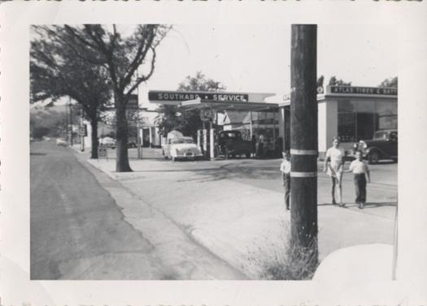
There have been a lot of changes since 1954 when R.B. Southard opened his first service station in Cloverdale on the corner of Lake Street and S. Cloverdale Boulevard. Cloverdale Auto Parts is located here now.

After graduation, Paul attended Shasta Community College for three years before returning to the business in 1985. He married the former Juli Parent in 1991 and they have three children, Jacob, Brandon and Angela.

Loyalty and service go hand in hand at Southard’s. Forty years after he first opened, R.B. says four of his original customers were still with him. Currently, their top mechanic, Luis Contreras, has been with them for 25+ years

Like any successful business, Southard Tire & Auto is continually adding new products and services to keep pace with their customers’ changing needs.
Still Cloverdale’s major tire shop, they also provide sales, service and repairs of front and rear suspensions, brakes, radiators, mufflers, tune-ups and computerized wheel alignments and balancing.

They also carry a full line of mufflers, tail pipes and catalytic converters, and with their professional pipe bending machine, can fully customize each job. Thanks to their Hunter GSP 9700 Vibration Control System, they are ride control experts.

R.B.’s formula for success – besides a lot of hard work – is really pretty simple. “Always give each customer the same kind of service you’d expect to receive.” He passed this advice on to Paul and Juli when they took over the business in 1994.

Since many consumers prefer shopping online, Southard is now a Recognized Installer for Tire Rack, the nation’s leading high performance products dealer. Juli says, “This means customers can order accessories and tires from www.tirerack.com and have them drop shipped to us. We can then schedule the installation of their order at a time convenient for them.”

With customers from Santa Rosa to Ukiah, it’s proving to be a very popular service.

Southard Tire & Auto is undisputedly the longest running retail and service oriented business in the history of Cloverdale.

Providing honest, dependable service at a fair price has worked pretty well for them the last 57 years. There aren’t many businesses today that can claim that unique distinction.

